Space Typing Game

Rules:

1. Kill all 100 words in 60 seconds with remaining life -> WIN

2. Time up with un-typed words or have no life -> LOSE

3. Different word has different falling speed, the quicker it falls the more score you will get after killing it.

4. Health will be deducted by one once the words touch the bottom line (ground).

Figures:

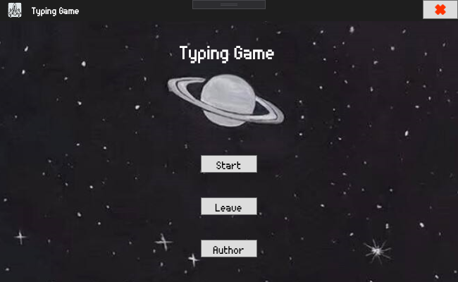

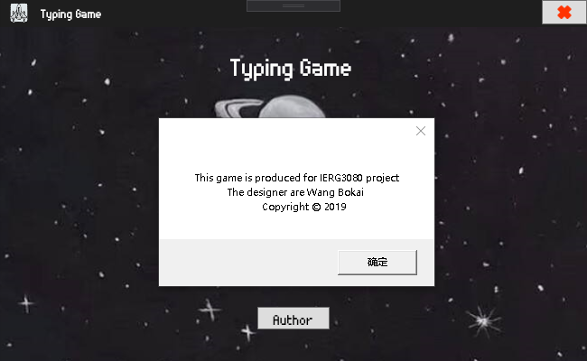

(Starting screen: Start to play the game; Leave and Red Cross to quit; Author: My name)

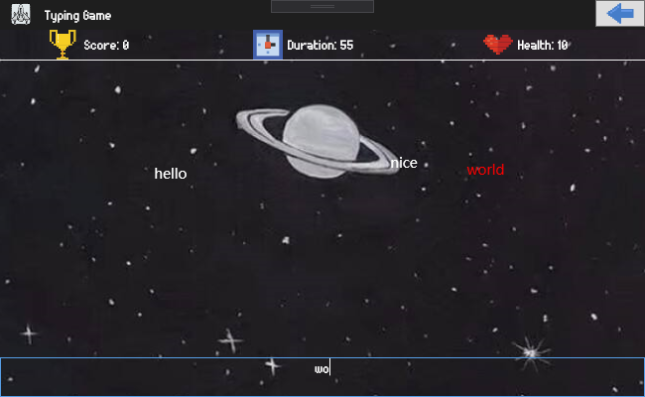

(GamePage: Score, Time, Health and the bottom space is for typing; Arrow to go back; The word you are conquering will become red to remind you)

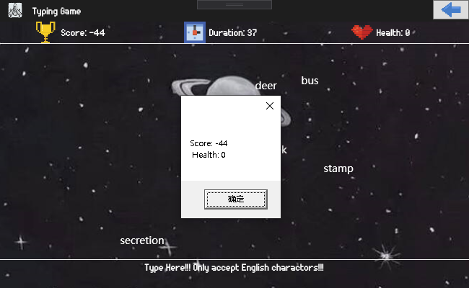

(Final Score and Health)

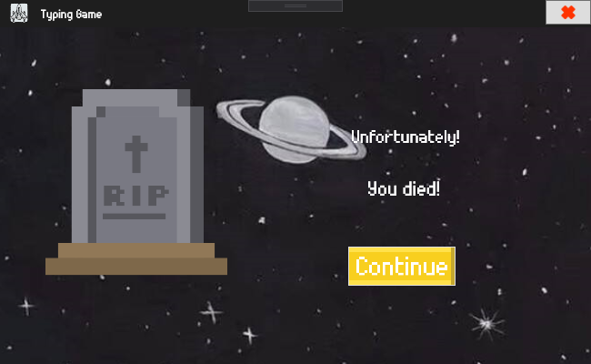

(Loss Screen: Continue to go back to Welcome Page -> Used to do different level in the future)

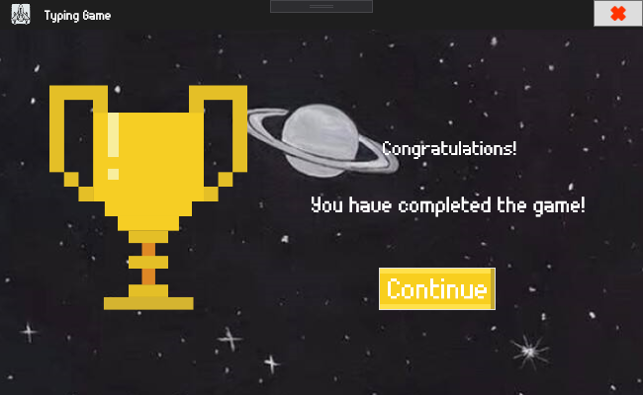

(Win Screen: Continue to go back to Welcome Page -> Used to do different level in the future)